

DBS Project Phase I
Name:
Muhammad Hasham Khan;
Sap ID:
70146312
Section:
BSCS-5A
Submitted To:
Sir Jawad Ahmad
Subject:
Database Systems

Project Description
This platform is designed to help track and manage personalized health optimization programs for individuals interested in improving their mental and physical performance. The system focuses on monitoring various wellness interventions, such as supplements, therapies, and lifestyle changes, and measuring their effects on each person's health and performance.
The database stores essential information about clients, including their personal details and health goals. It maintains records of their genetic information, which can help determine which interventions might work best for them based on their unique biology.
Database Schema
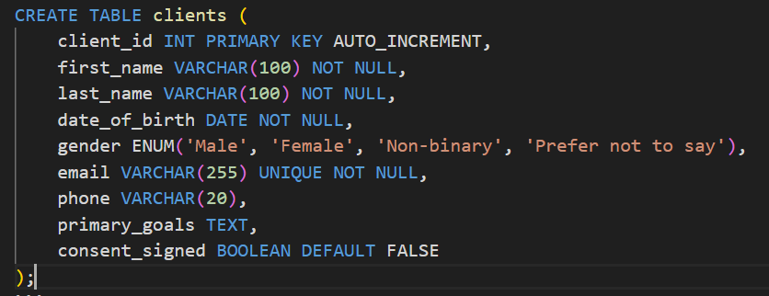
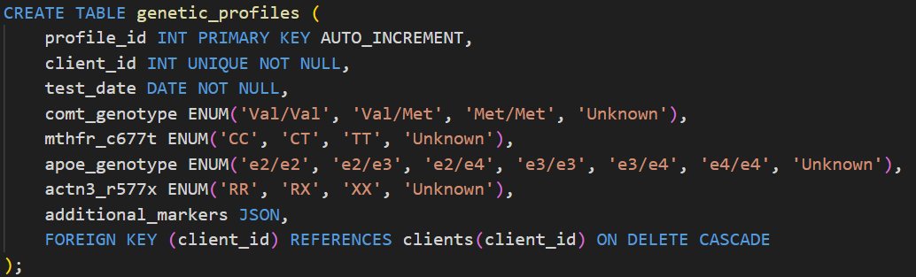
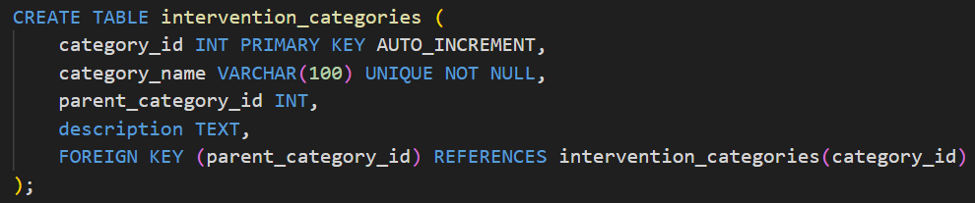
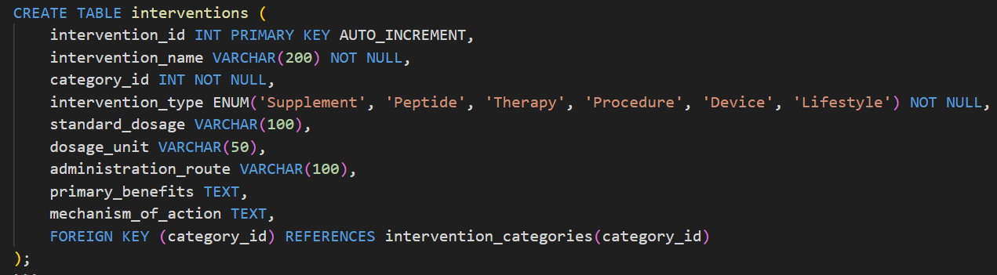
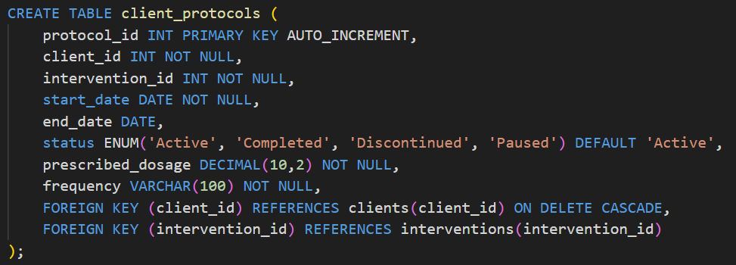
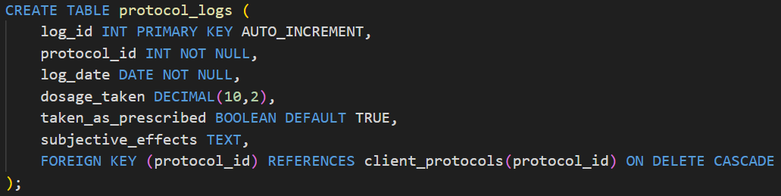
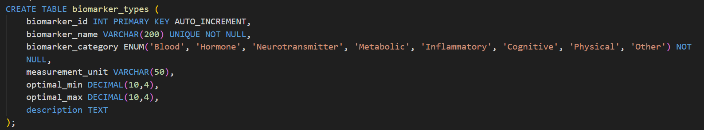
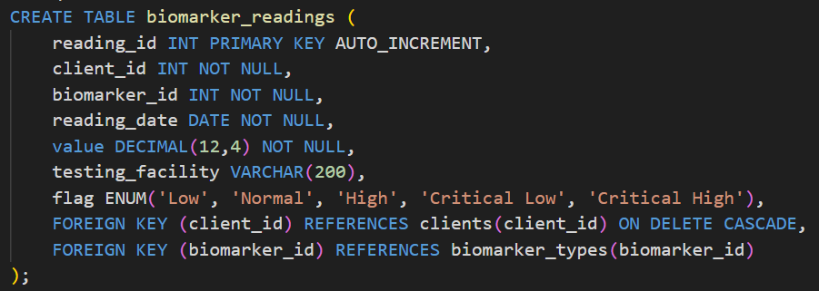
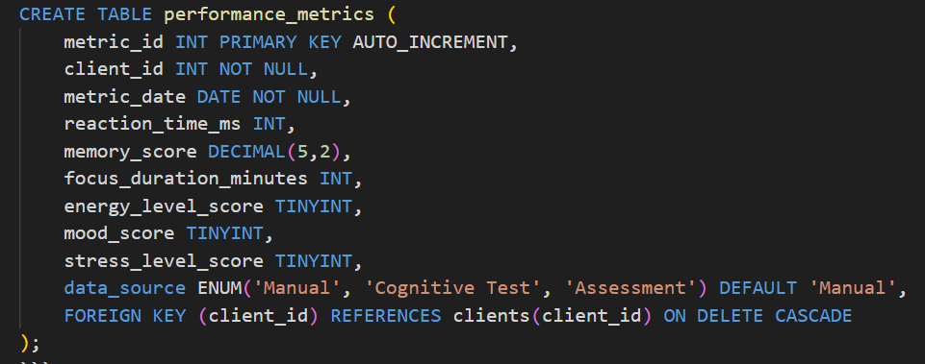

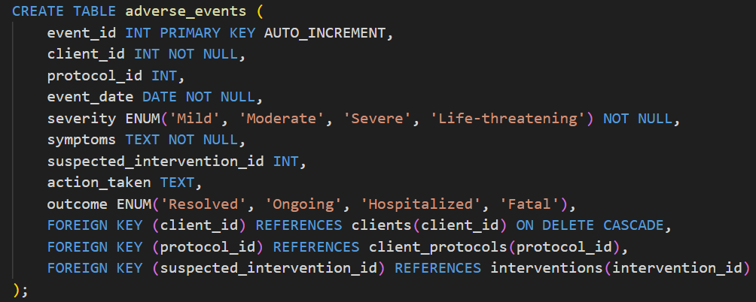
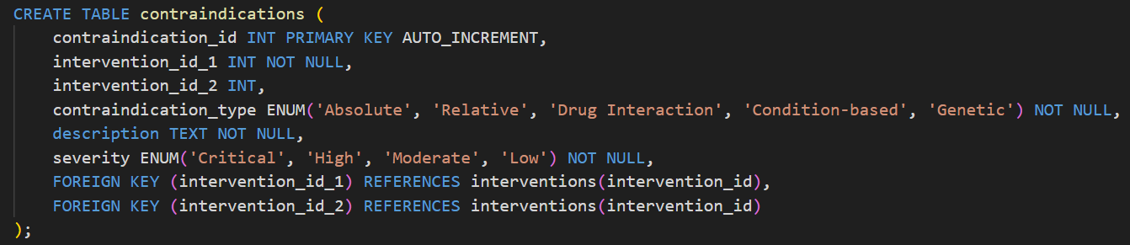
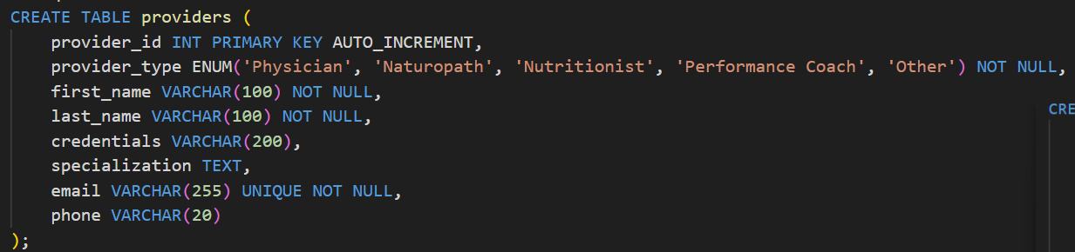
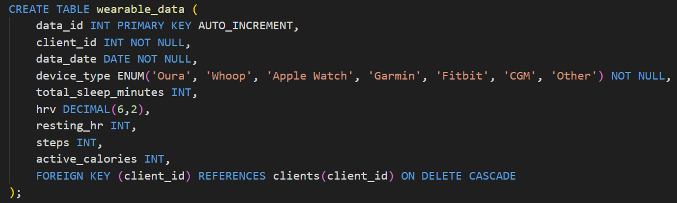
Relationships
- clients → genetic_profiles (One-to-One)
- clients → client_protocols (One-to-Many)
- clients → biomarker_readings (One-to-Many)
- clients → performance_metrics (One-to-Many)
- clients → adverse_events (One-to-Many)
- clients → wearable_data (One-to-Many)
- interventions → client_protocols (One-to-Many)
- interventions → contraindications (Many-to-Many via self-join)
- intervention_categories → interventions (One-to-Many)
- client_protocols → protocol_logs (One-to-Many)
- biomarker_types → biomarker_readings (One-to-Many)
Entity Relationship Diagram
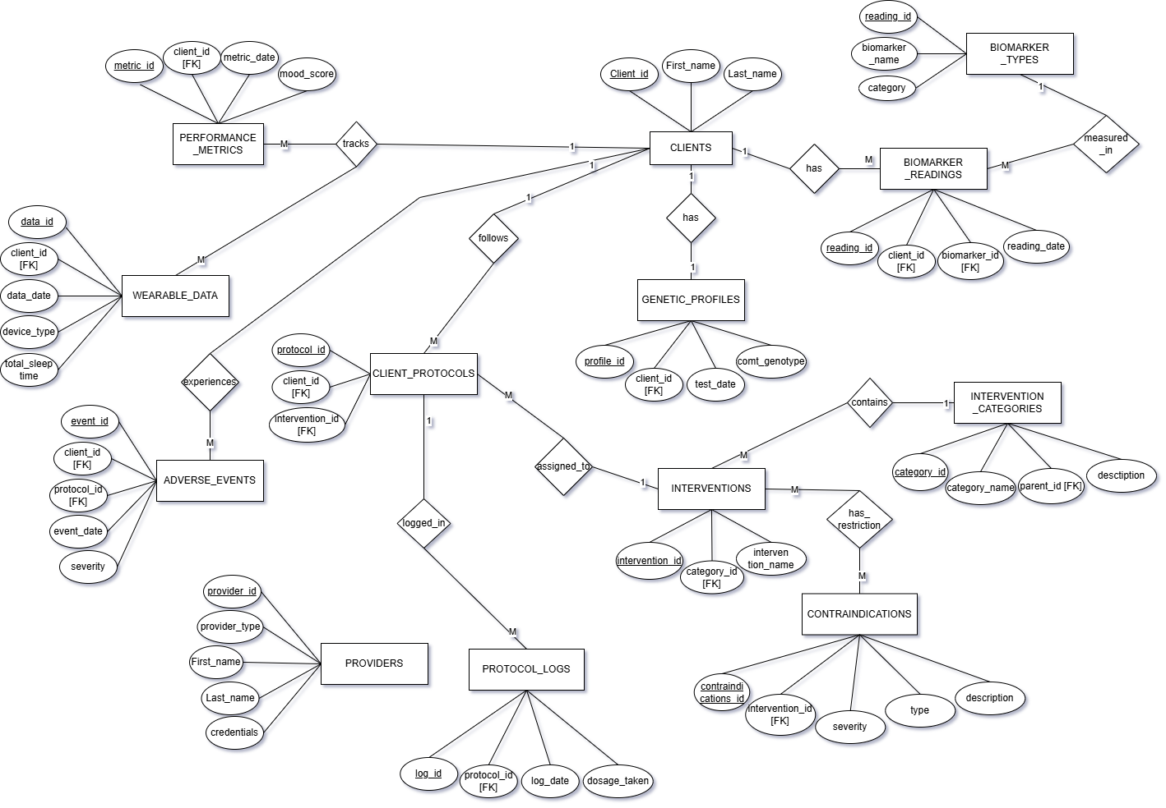

Rough ER Diagram From WorkBench
